


SEND policy and Information Report

Approved by: | Trustee Board | Date: September 2025
Next review due by: | September 2026

Contents
1. Aims and rationale 3
2. Legislation and guidance 3
3. Definitions 3
4. Roles and responsibilities 4
5. SEND Information report 5
6. Monitoring arrangements 10
7. Links with other policies and documents 10
8. Contact details for support services for parents of pupils with SEND…………………………………10
9. The Haybrook Way………………………………………………………………………………………………………11

……………………………………………………………………………………………………………………………

1. Aims
Our SEND policy and SEND information report aims to:
- Set out how our College will support and make provision for pupils with special educational needs / disabilities (SEND)
- Explain the roles and responsibilities of everyone involved in providing for pupils with SEND

Rationale
Haybrook College provides an education for young people with Social, Emotional and Mental Health difficulties and additional complex needs. At any one time, approximately half of our cohort have an Education, Health and Care Plan. The other young people do not have such a plan: however, their difficulties have been so significant that they have been unable to attend their local mainstream secondary school: we recognise that all pupils attending Haybrook College need SEND Support.
The ethos of the College is one of believing that all children have an entitlement to an outstanding education, regardless of their difficulties. Haybrook College’s core values of ‘Be Kind, Be Respectful, Be Ambitious’ are embedded in all we do.
All staff recognise the complexity of the needs of our cohort and addressing these barriers to learning underpins all that we do. Enabling the young people to access their education, achieve positive outcomes and be well prepared socially and emotionally in order to successfully ‘move on’ by sustaining employment, education or training remains our prime focus and is supported by our vision of ‘Inspiring and supporting young people to make positive decisions about the future’.

2. Legislation and guidance
This policy and information report is based on the statutory Special Educational Needs and Disability (SEND) Code of Practice and the following legislation:
- Part 3 of the Children and Families Act 2014, which sets out Colleges’ responsibilities for pupils with SEN and disabilities
- The Special Educational Needs and Disability Regulations 2014, which set out Colleges’ responsibilities for education, health and care (EHC) plans, SEND Coordinators (SENDCOs) and the SEND Information report

3. Definitions
A pupil has SEND if they have a learning difficulty or disability, which calls for special educational provision to be made for them.
They have a learning difficulty or disability if they have:
- A significantly greater difficulty in learning than the majority of others of the same age, or
- A disability which prevents or hinders them from making use of facilities of a kind generally provided for others of the same age in mainstream schools
Special educational provision is educational or training provision that is additional to, or different from, that made generally for other children or young people of the same age by mainstream school.

4. Roles and responsibilities

The SENDCo
The SENDCo for Haybrook College Trust is Carol Goodridge, and the Deputy SENDCo is Siân Rann.
They will:
- Work with the Executive Headteacher and SEND Trustee to determine the strategic development of the SEND policy and provision at the College
- Have day-to-day responsibility for the operation of this SEND policy and the co-ordination of specific provision made to support individual pupils with SEND, including those who have EHCPs
- Provide professional guidance to colleagues and work with staff, parents, and other agencies to ensure that pupils with SEND receive appropriate support and high-quality teaching
- Advise on the graduated approach to providing SEND support
- Advise on the deployment of the College’s delegated budget and other resources to meet pupils’ needs effectively
- Be the point of contact for external agencies, especially the local authority and its support services
- Liaise with potential next providers of education to ensure pupils and their parents / carers are informed about options and a smooth transition is planned
- Work with the Executive Headteacher and Trustee Board to ensure that the College meets its responsibilities under the Equality Act 2010 with regard to reasonable adjustments and access arrangements
- Ensure the College keeps the records of all pupils with SEND up to date

The SEND Trustee
The SEND Trustee will:
- Help to raise awareness of SEND issues at Trustee Board meetings
- Monitor the quality and effectiveness of SEND provision within the College and update the Trustee Board on this
- Work with the Executive Headteacher and SENDCo to determine the strategic development of the SEND policy and provision across the College

The Executive Headteacher
The Executive Headteacher will:
- Work with the SENDCo and SEND Trustee to determine the strategic development of the SEND policy and provision across the College
- Have overall responsibility for the provision and progress of learners with SEND

Class teachers
Each class teacher is responsible for:
- The progress and development of every pupil in their class
- Working closely with all support staff or specialist staff to plan and assess the impact of support and interventions and how they can be linked to classroom teaching
- Working with the SENDCo and Deputy SENDCo to review each pupil’s progress and development and decide on any changes to provision
- Ensuring they follow this SEND policy

5. SEND information report

The kinds of SEND that are provided for:
Haybrook College currently provides additional and/or different provision for a range of needs, including:
Social, emotional and mental health needs (SEMH)
In Haybrook College, this may simply present as challenging behaviours arising from either temporary or permanent social circumstances but could also include one or more of the following recognised disorders: Attention Deficit Hyperactivity Disorder (ADHD), Oppositional Defiance Disorder (ODD), A Conduct Disorder, Depression and anxiety
Communication and Interaction needs
In Haybrook College, this could include: Autism Spectrum Disorder (ASD), Attention Deficit Disorder (ADD), Social Communication Difficulties, Speech and Language Difficulties, (SLCN), including Developmental Language Disorder (DLD), Specific Learning Difficulty (SpLD)
Cognition and Learning needs
In Haybrook College, this could include pupils with some learning difficulties, as well as the delayed acquisition of skills in reading, writing, spelling and numeracy, for example
Sensory and/or physical needs
In Haybrook College, this may include possible physical disabilities, medical difficulties and a range of sensory processing difficulties and needs

Identifying pupils with SEND and assessing their needs
All pupils who attend Haybrook College are considered as having SEND Support, with many also having Education, Health and Care Plans, primarily for SEMH and additional complex needs.
We will assess each pupil’s current skills and levels of attainment on entry, which will build on previous settings and key stages, where appropriate. Class teachers will make regular assessments of progress for all pupils and identify those whose progress may be causing concern. This will also include progress in areas other than attainment, for example, social skills and emotional needs. Haybrook College uses the Boxall Profile to assess pupil’s social and emotional functioning and well-being.
Our SEND team assess all pupils using the WRAT5 test upon entry, and annually thereafter. If we have concerns that there may be additional Speech, Language and Communication Needs (SLCN) following the WRAT 5 testing, our Speech and Language Assistant will screen pupils. If it is felt a pupil requires assessment by the Speech and Language Therapist, this can be arranged with our Speech and Language Therapist. Using this information, we can then provide the appropriate interventions and share appropriate advice with teaching staff so their needs can be effectively met within the classroom.
In addition, we work closely with other professionals, including the Educational Psychologist (EP); Counsellors (No22 Counsellors); Occupational Therapists (OT); CAMHS; and the ASD Advisory Service to help identify and assess needs where appropriate. The Mental Health Support Team (MHST) also support us.

Consulting and involving pupils and parents
When deciding if additional provision is required beyond our core offer, we will consider the views and the wishes of the pupil and their parents / carers. Together, we will determine the support needed and whether we can provide it by simply adapting our core offer, or whether something different or additional is needed.
This will usually be done at Annual Review meetings for those with EHCPs, although we regularly review all aspects of progress and will be flexible with introducing additional provisions or interventions dependent on the pupil’s needs. We have an open-door policy where we are always happy to meet parents where we can, so that we can support them and their child however this may be needed.

Assessing and reviewing pupils' progress towards outcomes
At Haybrook College, we follow the graduated approach and the four-part cycle of Assess, Plan, Do, Review, through setting targets in all subjects each half term, in addition to SEMH targets.
The class or subject teachers under the guidance of the SENDCo will carry out a clear analysis of the pupil’s needs. This will draw on:
- The teacher’s assessment and experience of the pupil
- Their previous progress and attainment and behaviour
- Other teachers’ assessments, where relevant
- The views and experience of parents / carers
- The pupil’s own views
- Advice from external support services, if relevant
Pupil progress is reviewed every half term.
All teachers and support staff who work with the pupil will be made aware of their needs, the outcomes sought, the support provided, and any teaching strategies or approaches that are required. We will regularly review the effectiveness of the support and interventions and their impact on the pupil’s progress.

Supporting pupils moving between phases and preparing for adulthood
At Haybrook College, helping our pupils to successfully transition to new phases or new provisions is a key priority for all staff: assisting pupils to develop the necessary academic and social skills for sustaining success across the key stages and into adulthood is integral to our curriculum offer.
Pupils are carefully and thoughtfully inducted into their centre with bespoke induction packages if necessary. Pupils are well supported with transition to other provisions at any point in their time with us, but post 16 provision transition is especially comprehensive. our Careers Lead and her assistant, support pupils until the February of the following academic year, ensuring the support is consistent and still accessible to our pupils even after leaving Haybrook College.
All pupils have access to independent advice, information and guidance from a suitably trained professional and the programme offered by Haybrook College is comprehensive, and prepares our pupils well for adulthood.
For those pupils with EHCPs, during the Annual Review process, there are opportunities to discuss aspirations, future plans and preparing for adulthood with the pupil, their parent / carers, the Careers Leader, Deputy SENDCo, and the SEND Officer.

Our approach to teaching pupils with SEND and additional learning interventions
Teachers are responsible and accountable for the progress and development of all the pupils in their class. High quality teaching is our first step in responding to pupils who have SEND. This will be differentiated for individual pupils.
We will also provide the following learning interventions by members of the SEND team:
- Literacy interventions for pupils with SpLD with the Specialist Teacher
- Speech and Language programmes delivered by the Speech and Language Assistant
- Literacy interventions with the HLTA (Higher Level Teaching Assistant)
- Numeracy interventions with the HLTA
- Handwriting programmes with the HLTA
- Reading interventions with the Reading Intervention Mentor

Adaptations to the curriculum and learning environment

Our teachers use the ‘Haybrook Way’ (refer to page 11) to ensure pupils’ needs are met within their classroom. This is based on the Education Endowment Foundation’s research on how best to support learners with special education needs. Haybrook College is working towards achieving accreditation by ‘Better Communication’ to recognise our commitment to supporting pupils with speech, language and communication needs. The staff do this by:

- Using explicit instruction; cognitive and metacognitive strategies; scaffolding; flexible grouping and using technology in their teaching
- Using strategies that support pupils with speech, language and communication needs, such as visual timetables, visual resources, pre-teaching of vocabulary, giving longer processing times and checking understanding
- All pupils are provided with Access Arrangements for examinations if they have met the threshold for using scribes, readers and extra time and this is their normal way of working in classes.

Support for improving emotional and social development
Our teachers use the ‘Haybrook Way’ to ensure pupils develop their self-regulation skills and their emotional needs are met. This adopts the ‘Five to Thrive’ model, an evidence-based model utilising the latest neuroscience and research on attachment and trauma. They do this by following 5 steps in their interactions:
Respond ~ Engage ~ Relax ~ Play ~ Talk

We support our pupils to develop strategies that enable them to self-regulate through using the Zones of Regulation tool: this is used across all Haybrook College centres.
Many of our pupils need additional support so that they are more emotionally ready for learning. We can provide the following interventions for those pupils who would benefit from this specific support:
- Emotional Literacy programme with a qualified ELSA (Emotional Literacy Support Assistant)
- Social Skills small groups / individual work with HLTAs
- Counselling with a qualified Counsellor
- Equestrian Therapy (HALOs: Horse Assisted Learning Opportunities)
- Targeted Mentoring with a skilled team of mentors
We also work with the following professionals who can support learning at Haybrook College:
- Educational Psychologist
- Speech and Language Therapist
- Occupational Therapist
- ASD Advisory Service
- CAMHS
- MHST practitioners

Haybrook College has been awarded the ‘Attachment Aware Schools Award – Gold’ (July 2025) and the ‘Better Communication Accreditation’ (January 2025), in recognition of our trauma-informed approach, attachment awareness, and dedicated support for pupils with speech, language, and communication needs.
Expertise and training of staff
All Haybrook College staff are trained to a high standard and are involved in a continual programme of professional development. They have received recent training from our Educational Psychologist on Attachment Aware and Trauma informed practice and an extensive training programme in supporting young people with speech, language and communication needs. Our support staff have received training from our Educational Psychologists to ensure they are able to effectively support pupils with a wide range of learning needs. Our CPD programme is responsive to needs, and ensures our staff have the knowledge and understanding required to teach and support our pupils effectively.

Our SEND team are highly qualified and have the following qualifications:
- SENDCo: QTS, (Qualified Teacher Status) National Award for SENCO, Post Graduate Certificate in SEN, ELKLAN certificate (Speech, Language and Communication Needs qualification) The SENDCO is one of the College’s Deputy Head Teachers and is a full-time position
- Deputy SENDCo: QTS, currently working towards NPQSEN, ELKAN certificate (Speech, Language and Communication Needs qualification) This post is 0.8 fte (4 days per week) and works across the College
- Specialist Teacher: QTS, Dyslexia Action PG Certificate in Dyslexia and Literacy, ELKLAN certificate, Postgraduate Award of Proficiency in Assessment for Access Arrangements (PAPAA). This is a full-time post and covers pupils across all Haybrook College’s provisions
- Speech and Language Assistant: Speech Therapy Course Level 3, NCFE CACHE Level 3 Award in Supporting Children and Young People’s Speech, Language and Communication. This is a full-time post and covers pupils across all Haybrook College’s provisions, but primarily at Millside School
- HLTA: we have an HLTA who is trained to deliver SEND provision at Millside School and is a qualified ELSA. This is a full-time post and is based at Millside School
- Reading Intervention Mentor: our Reading Intervention Mentor is trained in delivering Rapid Plus reading interventions. This is a full-time post and is based at Millside School
- ELSAs: we have qualified ELSA’s in all Haybrook College’s provisions

We have a full-time Annual Reviews Officer who supports the SENDCo’s in managing and overseeing the Annual Review process for pupils with EHCPs.

Evaluating the effectiveness of SEND provision
We evaluate the effectiveness of provision for pupils with SEND by:
- Reviewing pupils’ individual progress towards their targets each half term
- Holding annual reviews for pupils with EHCPs
- Reviewing the impact of targeted interventions each term, in terms of progress, engagement and pupil’s views
- WRAT5 annual testing (sub-tests in Reading, Spelling, Maths and Comprehension)
- Boxall profile assessments
- Monitoring by the SENDCo / Deputy SENDCo

Enabling all pupils to engage in activities available to those in the College, regardless of SEND (all pupils at Haybrook College have SEND)
It is important to us that all pupils at Haybrook College regardless of their SEND needs have equal access to all aspects of learning offered, all enrichment activities and all reward trips (where earned.)
We adhere to the following principles to ensure we are fully inclusive:
- Our full curriculum offer, including enrichment / extra-curricular activities are available to all our pupils regardless of SEND
- All pupils are encouraged to go on any educational / curriculum trips we offer
- All pupils are encouraged to take part in sporting activities / special workshops, etc. No pupil is ever excluded from taking part in these activities because of their SEND
- All activities / trips offered by Haybrook College are free to pupils and therefore accessible to all, regardless of cost
- Pupils with physical disabilities can access all Haybrook College centres. There is a lift that can be used to access the first floor of the building at Springboard and Apollo, and all other centres are in single storey buildings with wheelchair access
- Haybrook College’s Accessibility Plan can be found on the Haybrook College website

Working with other agencies
At Haybrook College, we are committed to working with other professionals and practitioners to ensure that we maximise the impact of our work with pupils:
More specifically:
- We meet with our Educational Psychologist regularly to look at the needs of individual pupils, staff training and effectively tailoring our provision
- We work closely with our Speech and Language Therapist to assess and deliver interventions to pupils on SEND Support and those pupils with EHCPs
- We regularly liaise with professionals at CAMHS to discuss concerns or to refer pupils
- We regularly liaise with therapists at the MHST to discuss concerns or to refer pupils
- We liaise with professionals from Social Care where appropriate
- We take advice from the Occupation Therapy / Physiotherapy Team with regard to meeting specific pupil needs
- We liaise with the ASD advisory service for support and assessment of pupils needs

Complaints about SEND provision
At Haybrook College we are committed to providing pupils in our care with the best experience of education. However, if parents / carers are concerned or unhappy about any aspect of special educational provision for their child they should discuss the matter fully with the SENDCo / Deputy SENDCo, subject teacher and the Head of Centre.
In the event of the initial meeting failing to resolve the concern, the Executive Headteacher will hold a meeting to discuss the issue with the parents, any relevant teaching staff and the SENDCo.
In the event of continued dissatisfaction, parents / carers will be advised to take their complaint to the SEND Trustee or the Trustee Board.

Contact form for raising concerns

The local authority local offer
Our contribution to the local offer can be found on our website.

Our local authority’s local offer is published here.

Monitoring arrangements
Carol Goodridge will review this policy and SEND information report every year. It will also be updated if any changes to the information are made during the year. The Trustee Board will approve it.

Links with other policies and documents:
This policy links to the following policies: All policies can be found on the Haybrook College Trust website.
- Accessibility Policy and plan
- Behaviour Management Policy
- CEIAG Policy
- Equality Objectives
- Supporting Pupils with Medical Needs

Contact details of support services for parents of pupils with SEND

Slough SEND Information Advice and Support Service (SENDIASS)
For more information email sendiass@slough.gov.uk or call 01753 787693

Special Voices, Slough
For more information, email info@specialvoices.co.uk or call 07990 693439

The Haybrook Way

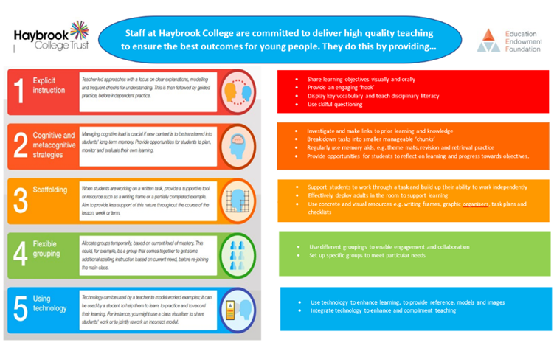
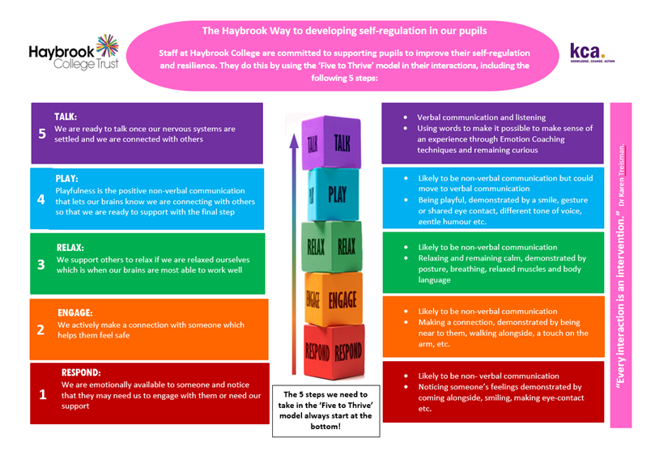
The ‘Haybrook Way’ for ensuring high quality teaching:
The ‘Haybrook Way’ for developing pupils’ self-regulation:

